21st September, 2020
Press Release

CENTRAL TRADE UNIONS SUPPORT
THE PEASANTS’ UNITED PROTESTS ON 25TH SEPTEMBER
DEMANDS BJP GOVERNMENT TO STOP DESTRUCTIVE ANTI FARMER MEASURES
CALLS FOR COUNTRYWIDE SOLIDARITY ACTIONS BY WORKERS

The joint platform of Central Trade Unions and sectoral federations declares its unstinted support to the initiative of Joint Platform of Peasants and Agricultural Workers Organisations –the All India Kisan Sangharsh Coordination Committee to hold Countrywide Protest and Resistance on 25th September 2020 through massive demonstration, Rail Roko, Rasta Roko etc against the anti-people, anti-farmer destructive legislations being pushed through by the BJP Govt at the centre which was preceded by Ordinances in an authoritarian manner. We also join them in protesting against the disastrous Electricity Amendment Bill 2020.

CTUs and sectoral federations call upon the workers and their unions of all affiliations and across the sector to join actively in the programmes of protest and resistance being organised by the peasants’ organisations in and around their respective areas.

The anti-farmer, anti-people move of the Govt have been initiated by three Ordinances which are aimed at completely restructuring the management of the agricultural economy including farm trade in total favour of the big-landlord corporate nexus and multinational trading cliques on agricultural produce. They virtually kill the rights and entitlements of the agricultural population. The Essential Commodities Act and related anti-hoarding, anti-black-marketing regulations are going to be curbed. The virtual withdrawal of Govt’s role in ensuring fair and remunerative prices for farmers’ produce will pave the way for ultimate doing away with Govt procurement of agricultural produce with minimum support price. In totality, peasant agriculture will be totally ruined, on which survival of more than sixty percent population is dependent. These measures would recklessly promote contract farming at terms and prices dictated by big landlord-corporate nexus including foreign trading cliques, who would usurp monopoly power. Mass of the non agricultural population will also be severely affected and put in miseries since the food security of the country is going to be endangered under new dispensations. The new measures are also aimed to facilitate profiteering by big players like Adani, Wilmar, Reliance, Walmart, Birla, ITC etc and also the large trading companies, both foreign and domestic.

Two of these destructive ordinances have already been converted into laws in the ongoing Parliament session. They are patently unconstitutional as they encroach upon State subject, destroying federalism in the process. Hence defiance and resistance with a determination not to allow these destructive measures to be implemented in our agricultural economy is the only way before the people. The joint countrywide action by All India Kisan Sangharsh Coordination Committee (AIKSCC) on 25th September 2020, which may turn into total Bandh in Punjab and Haryana and series of blockades in every corner of the country, is therefore a necessary action to protect the farmers, the food security and the country’s economy. The working class movement firmly stands by it.

CTUs and Federations reiterate their solidarity and support to the call for countrywide protest and resistance actions by peasants on 25th September 2020 and any united actions later on in states and call upon the working people to extend support and organise solidarity programmes across the sectors.
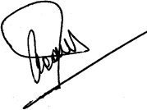 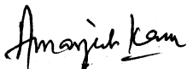 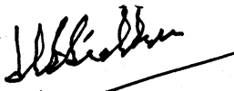 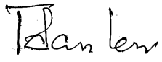 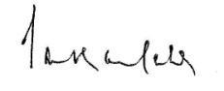 INTUC AITUC HMS CITU AIUTUC
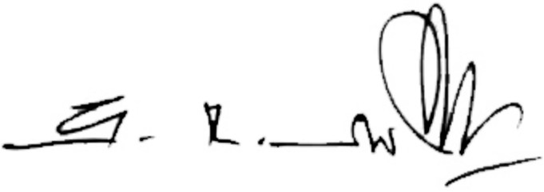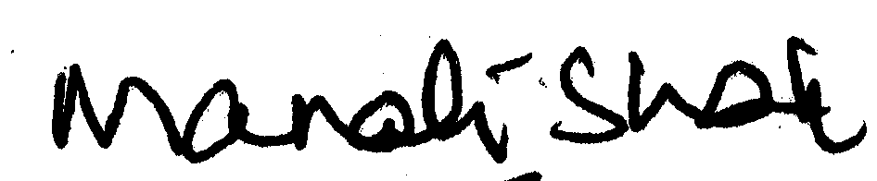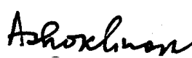
TUCC SEWA AICCTU LPF UTUC
And Sectoral Federations and Associations

